Working with Expanse Services: What to Expect
Todo: Minimal version, detailed version
- Showcase your company’s awards, certifications, and notable achievements to demonstrate your credibility and expertise.
- ( website? )
Layout Options: Timeline?
Also, over time. Can just put in text for now.
Introduction ( Need new title )
At Expanse Services, we're not just software developers; we're passionate innovators driven by a commitment to transparency, continuous improvement, and optimization. We meticulously craft top-notch software solutions, always striving to deliver them on time and within budget. Our commitment to equity and equality extends beyond our work, creating a nurturing environment where individuals from all walks of life can flourish and reach their full potential.

Project Approach and Methodology
Goal: Outline your project management approach, emphasizing clear communication, collaboration, and transparency throughout the development process.
Explain your preferred methodology, such as Agile or Waterfall, and how it aligns with the project's requirements and client preferences.

< Learn More > ( Our process Section Home Page )

Self written
We prefer to use an Agile development approach for software development. Software development flows through 3 main phases: Planning, design, build ( Plan, create, build ). We start by understanding our project then we begin to visualize the vision, and continuously iterate our build process focusing on the most important pieces.
Depending on the specific needs of the client and project we have an array of testing, quality assurance, development decisions, communication options, and process and procedure variations to make sure we get the right fit.

At Expanse Services, we embrace an Agile development methodology that prioritizes flexibility, adaptability, and continuous improvement. This approach allows us to seamlessly align with your evolving needs and deliver software solutions that perfectly match your unique business objectives.

Revision 1 – Process Page
Our process flows through three core phases: Planning, Design, and Build. We begin by conducting a thorough needs assessment to fully grasp your vision and goals. Next, we transform your vision into comprehensive designs that outline the user experience, functionality, and technical architecture. Throughout the development process, we iterate and refine our approach, focusing on the most critical elements first. This ensures that your project remains on track and delivers the features and functionality you need to achieve your goals.
Revision Round 2: Process page text
Our streamlined process seamlessly guides your project from vision to reality. Our three core phases – Planning, Design, and Build – ensure clarity, efficiency, and continuous improvement.
We begin by conducting a thorough needs assessment to fully understand your goals and challenges. Next, we transform your vision into comprehensive designs that outline the user experience, functionality, and technical architecture. Throughout the development process, we employ an iterative approach, prioritizing the most critical elements first. This ensures that your project stays on track and delivers the features and functionality you need to achieve your objectives.

Revision engaging – Home Page
We embark on your digital journey by delving into your business goals and user needs through a comprehensive needs assessment. We then translate your vision into detailed wireframes and prototypes that bring your ideas to life. Throughout the development process, we continuously adapt and fine-tune our approach, focusing on the most critical elements first. This ensures that your project remains on track and delivers the features and functionality you need to achieve your goals.

Revision round 2 - home page
We embark on your digital journey with a comprehensive needs assessment, delving into your business goals and user needs. We then transform your vision into detailed wireframes and prototypes, bringing your ideas to life. Throughout the development process, we continuously adapt and fine-tune our approach, focusing on the most critical elements first. This ensures that your project remains on track and delivers the features and functionality you need to achieve your goals.

Title: Your Digital Journey Starts Here
Unlocking Digital Success: How We Work
Comprehensive needs assessment: This demonstrates your commitment to understanding your clients' needs and goals.
- Translation of vision into wireframes and prototypes: This showcases your ability to bring your clients' ideas to life.
- Adaptive and iterative development approach: This emphasizes your flexibility and focus on delivering the most critical features first.

Client Benefits and Outcomes ( Top ? )
- Emphasize the benefits your company brings to clients, such as reduced risks, improved time-to-market, and increased cost-efficiency.
Showcase successful client case studies and testimonials to demonstrate your track record of delivering high-quality software solutions.

[Planning Phase]

Embark on Your Digital Journey: Discussing Your Vision
// Clarify: in this phase we get the high level details
The first meeting with Expanse marks the beginning of an exciting journey to transform your vision into a reality. This crucial step lays the groundwork for a successful collaboration, ensuring that your goals, expectations, and needs are clearly understood and aligned.

Articulate Your Vision, Goals, and Expectations
This is your opportunity to share your vision for the project, outlining your goals, objectives, and desired outcomes. Expanse will actively listen and ask clarifying questions to gain a comprehensive understanding of your requirements and aspirations.

Define the Project Scope and Deliverables
Together, you will start to define the project's scope, outlining the specific features, functionalities, and deliverables that will bring your vision to life. This collaborative process ensures that both parties are on the same page, preventing scope creep and ensuring that the project remains focused on achieving your desired outcomes.

Establish Realistic Timelines and Budget
The discussion will delve into the project's timeline, considering its complexity and your budget constraints. Realistic timelines will be established, ensuring that your project progresses smoothly and stays within your financial parameters.

Explore Technology and Design Options
Expanse will provide insights into potential technology stacks and design approaches that align with your project's requirements and aesthetic preferences. This exploration will help you understand the technical feasibility and envision the overall look and feel of your website or application.

Address Concerns and Questions
Your questions and concerns are taken seriously. This is the time to address any doubts or uncertainties you may have about the project. Expanse will provide clear and comprehensive answers, ensuring that you feel confident and informed throughout the process.

Establish Next Steps and Communication Channels
The meeting concludes with a clear understanding of the next steps, including follow-up actions, communication channels, and timelines for project updates. This leaves you with a roadmap for the path ahead, ensuring that you stay informed and involved every step of the way.
As you embark on this exciting journey, remember that Expanse is here to guide you and support you. Their expertise and dedication will be instrumental in transforming your vision into a successful digital solution.

< Schedule a Free Consultation CTA >

Draft Initial Project Proposal

Discovery and Requirements Gathering: Defining Project Essentials ( Formal Requirements Documentation )
Title options
From Vision to Spec:
Unveiling the Blueprint: Detailed Requirements Gathering and Project Planning
Crafting a Comprehensive Project Proposal
Shaping Your Digital Blueprint: Formalizing Requirements
// Clarify: In this phase we dive into more detail.

Questionnaire & Discussion
We dive deeper into the details of what we are building. Asking questions and expanding on details such as:
More detail on design aspects

Diving deeper into requirements such as which images should be included, what pages do you want, what are your priorities for development,
Discuss technology, hosting, design

Then we begin gathering information specific values such as social media links to include, images to include, services offered, ranking the priority of the featured items or images, categorizing images, design preferences,
We discuss priorities and mandatory requirements, optional requirements, and define the priority of different elements.

~We may discuss release preferences.
We may briefly discuss a release schedule and plan for releasing your website ( i.e. do you want all features finished before releasing or would you prefer to release your software incrementally. Likely a combination of both )
Is there a preferred day and time of release?

We may discuss testing requirements and preferences.
Organizing

→ We sign a contract

Initial Writing
Crafting a Comprehensive Project Proposal
- Refining Project Scope and Deliverables: Clearly defining the project's scope, deliverables, and objectives to ensure alignment with your vision.
- Prioritizing Requirements: Identifying and prioritizing mandatory, optional, and deferred requirements to ensure efficient resource allocation.
- Establishing Testing Strategies: Discussing testing requirements, preferences, and methodologies to ensure quality assurance throughout the development process.
- Defining Release Preferences: Determining the desired release cadence, whether it's continuous deployment or scheduled releases.
- Finalizing the Project Proposal: Completing the formal project proposal, outlining the scope, deliverables, timeline, budget, and risk mitigation strategies.
- Deciding on Integration Requirements: … Social Media …
- Deciding on High Level Technical Architecture
- Planning for User Experience, writing User Journeys, and creating User Stories

Exploring Design Directions and Preferences
- Gathering Design Preferences: Understanding your design preferences, including color palettes, typography, and overall aesthetic direction.
- Categorizing Images: Classifying images based on their intended use, such as product images, background images, or hero images.
- Ranking Featured Elements: Determining the priority of featured items or images to prioritize their placement and prominence.
- Collecting Social Media Links: Gathering accurate social media links to ensure seamless integration into the website or application.
- Creating Wireframes: Utilizing wireframes to visualize the layout and structure of key pages, providing a rough outline of the user interface.

Revision Writing round 2
Phase 2: Crafting a Comprehensive Project Proposal
In this phase, we meticulously refine the project's scope, deliverables, and timeline, ensuring perfect alignment with your vision and objectives. We also delve into your design preferences and create wireframes to shape your digital blueprint.
Refining Project Scope and Deliverables
Through comprehensive collaboration, we refine and expand upon the project's scope, deliverables, and objectives, ensuring we capture every aspect of your vision and requirements.
Prioritizing Requirements
We work together to identify and prioritize mandatory, optional, and deferred requirements. This prioritization ensures that we allocate resources efficiently and focus on the most critical aspects of the project first.
Establishing Testing Strategies
We discuss testing requirements, preferences, and methodologies to establish a comprehensive quality assurance plan. This plan ensures that your project is rigorously tested throughout the development process.
Defining Release Preferences
We determine the desired release cadence, whether it's continuous deployment or scheduled releases. This decision is based on your preferences, project complexity, and business needs.
Finalizing the Project Proposal
We complete the formal project proposal, outlining the scope, deliverables, timeline, budget, and risk mitigation strategies. This proposal serves as a comprehensive roadmap for the project's execution.
Discussing Integration Requirements
We discuss integration requirements, including social media integrations, third-party APIs, and legacy systems. This ensures that your project seamlessly integrates with your existing infrastructure.
User Experience Planning
We meticulously plan the user experience (UX) to ensure a seamless and intuitive user journey. This includes writing user journeys, creating user stories, and gathering design preferences.
Gathering Design Preferences
We understand your design preferences, including color palettes, typography, and overall aesthetic direction. This ensures that the project's design aligns with your brand and vision.
Categorizing Images
We classify images based on their intended use, such as product images, background images, or hero images. This organization facilitates efficient image selection and management throughout the design process.
Ranking Featured Elements
We determine the priority of featured items or images to prioritize their placement and prominence. This prioritization ensures that the most important elements are showcased effectively.
Creating Wireframes
We utilize wireframes to visualize the layout and structure of key pages, providing a rough outline of the user interface. This low-fidelity approach allows for early feedback and iteration.
Deciding on High-Level Technical Architecture
We collaborate to decide on the high-level technical architecture, including the choice of programming languages, frameworks, and tools. This decision is based on the project's requirements, scalability needs, and future growth plans.
By following these steps, we can craft a comprehensive project proposal that accurately reflects your vision and objectives. This proposal will serve as a valuable guide throughout the project's development and ensure that we deliver a solution that meets your exact needs.

[Design Phase]
Layout Options:
- Two-column layout: Divide the content into two columns, one for the design process and the other for the technical architecture. This layout provides a clear visual distinction between the two aspects.
- Accordion layout: Use an accordion-style layout to collapse and expand sections, allowing users to focus on one aspect at a time. This layout is particularly useful for websites with limited space.
- Tabbed layout: Implement a tabbed layout to switch between the design and technical sections. This layout offers a user-friendly interface for navigating between different aspects of the process.

Envisioning Success: Transforming Your Vision into Interactive Prototypes and Robust Technical Architecture
Before delving into the intricacies of coding, we embark on a comprehensive design journey, encompassing both visual and technical aspects. We utilize the power of Figma, an interactive prototyping platform, to translate your vision into high-fidelity mockups. This collaborative space allows us to refine and iterate on the design before committing to code. Simultaneously, we lay the foundation for a robust technical architecture, ensuring optimal performance, scalability, and security.

Visualizing Success: Translating Your Ideas into Prototypes
Our design process begins with Figma, an interactive platform that enables us to bring your project to life through mockups and prototypes. [Transition needed]
- Designing for User Experience: We prioritize user experience, designing intuitive layouts, navigation structures, and process flows that enhance user interactions.
- User Interface Components: We meticulously create individual user interface components considering usability, accessibility, and visual appeal. We maintain consistency across the entire project, ensuring that every element—from intuitive buttons to aesthetically pleasing icons—is seamlessly integrated and enhances the user experience.
- Gathering Content Sources: We identify and gather relevant content, including text, images, and videos, to ensure a rich and engaging user experience. This content serves as the foundation for crafting compelling narratives and visuals.
- Gathering Exact Values: We gather precise values for elements like email addresses, phone numbers, and images, including logos and other graphical elements, to ensure accurate representation throughout the website or application.
[ Figma Image/Video and/or Link ] [WRONG ICON in img]
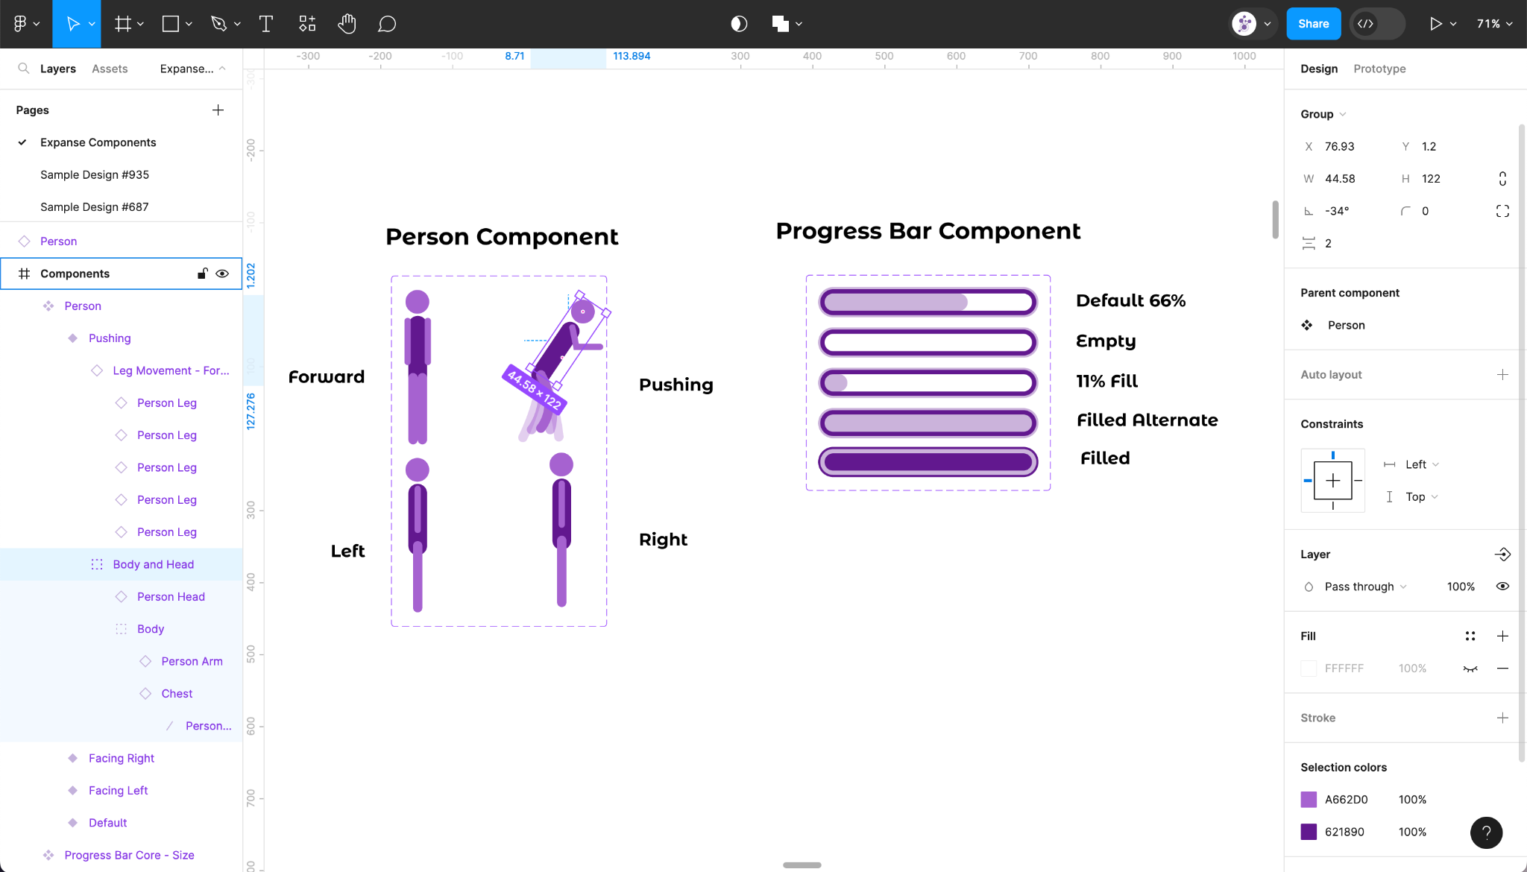
[Also process page]
Unveiling the Technical Blueprint
As we meticulously craft the visual elements of your web application, we simultaneously lay the groundwork for its technical backbone. This includes:
- Defining API Design Specifications: We collaborate with you to define the API design specifications, ensuring seamless integration with third-party services and data sources.
- Designing Infrastructure: We carefully design the infrastructure of your website or application, ensuring optimal performance, scalability, and security. We consider factors such as traffic volume, data growth, and security protocols to ensure that your application can handle the demands of your users and protect their data.
<CTA>
Unleash your Potential
<Get Started>
Elevate Your Digital Presence
<Begin Journey>
<Get A Quote>
Begin your Journey

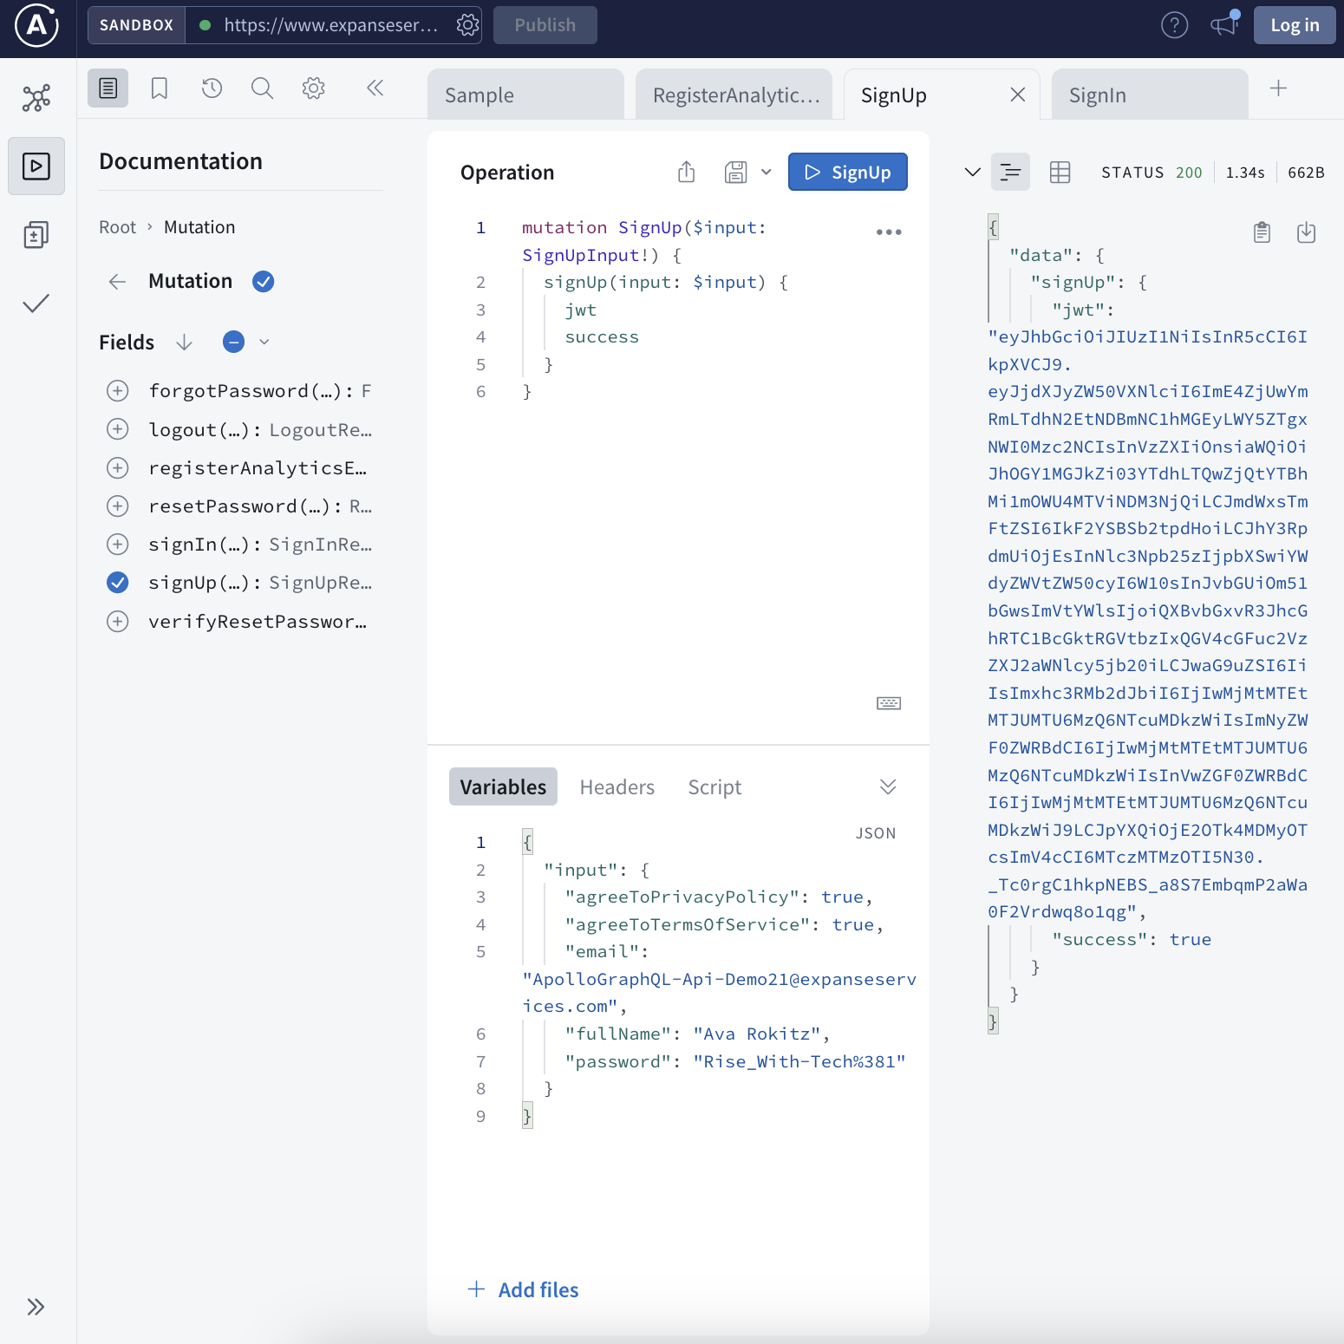
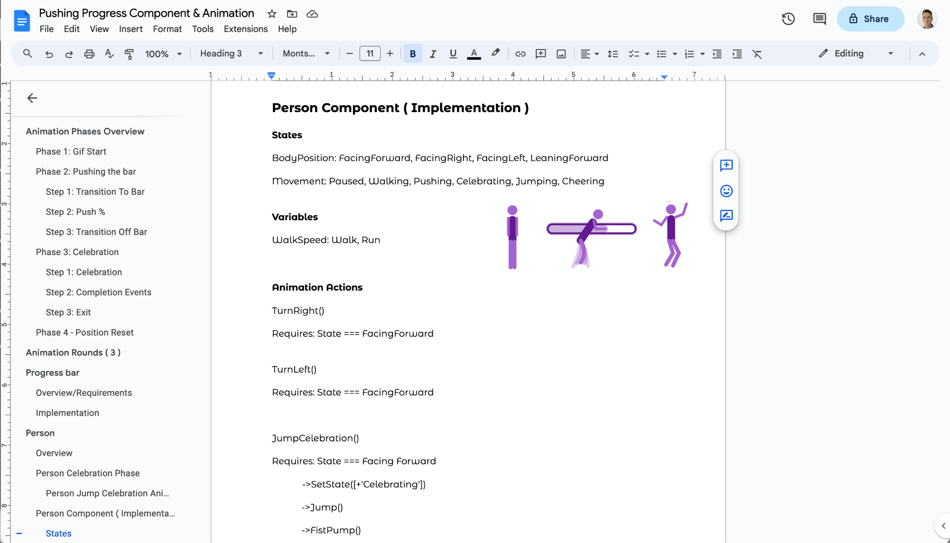
[ API Image/Video and/or Link ]
[ Animated character specifications ]

[Development Phase]
Powered by state-of-the-art technology, our development process creates applications with lightning speed. With JavaScript and TypeScript as our foundation, we specialize in delivering products that offer performance, scalability, and reusability. Our solutions seamlessly operate within cloud or self-hosted platforms.
Preferred Technologies
- UI: React, Angular, JavaScript
- Server Side: Docker, Express, Node.js
- Databases & Data: MySQL, MongoDB, JSON
- Open source & Tooling: OpenAI, Git, Webpack
- Design Patterns: GraphQL, REST, Serverless

Application Hosting, Deployment, and Operations
Whether you're managing your own solution or seeking assistance with deploying to a cloud environment, count on us to launch your application seamlessly. Looking for unmatched scalability through serverless solutions and swift content delivery? We've got you covered.
Expanse offers:
- Cloud Hosting with services such as Gcp, Aws, and Acp
- Serverless Computing solutions through AWS Lambda, Google Cloud Functions, and alternative providers
- Streamlined Development Processes including Version Control Strategies for Branching and Committing, Deployment Pipelines, and Continuous Integration
This Includes:
- Server Setup with Physical Machines, Ram, Cpus, load balancing, dns, and common backend setups
- Data Repositories such as Relational Databases, NoSQL Databases, and File System Storage
- Cloud Service Implementations encompassing text Messaging, Emailing, and Text-To-Speech

Agile Development
In order to keep projects organized and ensure unified communication, Jira is our tool of choice. Explore the interface depicting intricacies of software project management through the accompanying image, showcasing vital elements like tickets, complexity estimates, statuses, prioritization, and epics.
[Picture of Jira]
[Picture of Sprint] [ Picture of Kanban ? ]
~[Picture of Jira Ticket]

Predicting Project Complexity: Development Estimation Techniques
We employ a point-based system to gauge the complexity of tasks, akin to estimating the approximate completion time without assigning it to a specific individual. This approach fosters a more objective and consistent assessment of effort across tasks, paving the way for a more streamlined and efficient development process. This point-based agile development model elevates development to a new level of precision and predictability.
[Expanse point estimation component & chart/table]

<Ready to grow your business?>
<Contact Us>

Contact Information and Next Steps
- Provide clear contact information for inquiries and project discussions.
- Outline the next steps for initiating a project, including proposal submission, contract negotiation, and project kickoff.
Client Benefits and Outcomes ( Top ? )
- Emphasize the benefits your company brings to clients, such as reduced risks, improved time-to-market, and increased cost-efficiency.
Showcase successful client case studies and testimonials to demonstrate your track record of delivering high-quality software solutions.

Additional Information

Eventual Link: Project Timeline, Pricing, and Quotes ( Page )

Eventual Link: Software Testing

Eventual Link: Deployment & Maintenance

Eventual Link: Task & Ticket Management

Eventual Link: Communication & Progress reporting during projects
Project Timeline

FAQs
We dynamically adapt our methodology based on the specific demands of each client and project, employing a variety of testing, quality assurance, and development strategies, communication methods, and process adjustments to achieve optimal results.

Communication and progress reporting during a project
- Track the progress of features and tasks in online product management dashboards.
- Stay in the loop with project-specific Zoom meetings.
- Receive instantaneous updates via Text, Email, and/or Slack, keeping you informed about project events through team messages.
<Depends on the project>
Q: How do you keep clients informed about project progress?
We prioritize clear and consistent communication throughout your project. Track progress in real-time through our online dashboards, attend project-specific Zoom meetings, and receive instant updates via Text, Email, or Slack. Our communication style adapts to each project's unique needs.

- Highlight your commitment to open and transparent communication with the client throughout the project lifecycle.
- Explain your use of project management tools and regular meetings to keep the client informed and involved in decision-making.
- Track the progress of features and tasks in online product management dashboards.
- Stay in the loop with project-specific Zoom meetings, including roadmap updates, backlog grooming, and daily stand-ups.
- Receive instantaneous updates via Slack, Text, or Email, keeping you informed about project events through team messages.
Development Practices
- Highlight your development practices, including coding standards, code reviews, to ensure high-quality code and software stability.

Deployment and Maintenance
Explain your deployment process, including staging environments, rollouts, and user training to ensure a smooth transition to production. Describe your maintenance and support plans to address any post-deployment issues and provide ongoing updates and enhancements.

Software Testing & Quality Assurance ( Page )

Design Options / Design Explained

Task and Ticket Management
The chunked categories and pieces are broken down further and put into our project management software. Additional details are added to the tickets such as descriptions and types of work types. Tickets have status tracking (generalized as Todo, Doing, Done) and allow for commenting, assignment, and prioritization. They enable communication and record keeping track for what is and has been done with each piece of work.

~Breaking It Down: Simplifying the Project ( Simplification & Chunking)
Break down work into categories and organized sections and types of work to be done. We are breaking down the work into smaller bite sized pieces that we use to track the progress of your project. To keep things organized we have categories
Example:
We want a website with a header, footer, navigation, a home page and an about us page.
→
Web Hosting
Domain
Emailing
Credentials
Cloud platform setup
Databases
Design, Development, Content
Layout
Header
Footer
Navigation
Home Page
Banner
Hero Section & Text
Featured Content & Text
Call To Action
Testimonials
About Page
Mission Vision Values Section
Team Members
Contact Information
FAQs
Components
Call to Action
Contact Us
Social Media Links

Project Timeline, Pricing, and Quotes ( Eventual Page )

Understanding Project Costs and Timeframes
At Expanse, we believe in transparency and clarity throughout the project development process. Our approach to quoting, pricing, and timeline ensures that you have a comprehensive understanding of the project's scope, costs, and expected delivery dates.

Initial Estimation and Formal Quote
Upon receiving your project requirements, we provide a preliminary estimate based on the project's scope, complexity, and our expertise with similar projects. Once you agree to this preliminary estimate, we gather more detailed information, prepare formal requirements, and present you with a comprehensive quote outlining the estimated costs, including labor, materials, and software licenses.

Project Timeline
The project timeline is determined based on the project's complexity and the availability of resources. Once we have a clear understanding of your requirements, we provide a preliminary timeline for project completion. If the preliminary estimate is approved, we move into the formal requirements phase, where we finalize the timeline, define milestones, and establish clear expectations.

Contract Types
We offer a variety of contract types to suit the specific needs of each project. Our contract types include:
- Fixed-Price Contract: Expanse commits to delivering the project for a predetermined fixed price, regardless of the actual effort or time required. This approach is suitable for projects with well-defined scope and minimal uncertainty.
- Time and Material (T&M) Contract: Expanse charges the client for the actual time spent on the project and the cost of materials used. This approach offers flexibility and adaptability for projects with evolving requirements or unforeseen complexities.
- Value-Based Contract: Expanse and the client agree on a value proposition and define milestones with associated value increments. Payment is based on the value delivered at each milestone. This approach focuses on value realization and aligns incentives between the client and Expanse.
- Hybrid Contract: A combination of fixed-price and T&M elements, often used for projects with a defined scope but some uncertainty in complexity. This approach balances predictability and flexibility.

Choosing the Right Contract
The choice of contract type depends on the project's scope, complexity, risk profile, and the risk tolerance of both the client and Expanse. We carefully evaluate each project and recommend the most suitable contract type to ensure a successful project outcome.

Commitment to Transparency
Throughout the project lifecycle, we maintain open communication and provide regular updates on progress, costs, and any potential challenges. We believe in transparency and collaboration to ensure that your project aligns with your expectations and delivers the desired results.

